**Planning Memo**

**Jarred Randall & Sylvanus Duamor**

**Introduction**

The Metropolitan Planning Organization (MPO) for the Atlanta region is poised to lead a transformative urban planning initiative to shape the metropolitan landscape through 2031. This planning memo leverages historical and contemporary data on land use, demographics, and transportation to anticipate the evolution of urban sprawl and land use conversion over the next decade. We aim to provide a data-driven foundation for strategic development that aligns with sustainable growth objectives.

**Data Collection and Preparation**

Our analysis began with an extensive data collection phase, sourcing high-resolution land cover data from the National Landcover Database (NLCD) and compiling comprehensive datasets on land use, population dynamics, and development indicators from federal, state, and local databases for the years 2011 and 2021. This data aggregation has enabled us to identify significant trends and patterns in land development, forming the basis for our predictive modeling efforts.

**Exploratory Data Analysis:**

Figure 1 Atlanta MSA Landcover for 2011 & 2021 NLCD

**Land Cover Changes**: Our initial examination focused on the transition in land cover categories over the past decade. Notably, areas previously categorized under forest and farmland have undergone considerable development. The analysis of these transitions, depicted in our development change maps, reveals a trend towards increasing urbanization in previously rural or undeveloped areas.

Figure 2 Percent Atlanta MSA Developed

This series of maps presents a compelling visualization of urban development in Atlanta from 2011 to 2021. The first two maps highlight the spread of developed areas (shown in red) in 2011 and 2021, demonstrating significant urban expansion over the decade, particularly in central and surrounding districts. The third map provides a focused view on changes in development, where green dots represent areas that transitioned from undeveloped to developed status, illustrating targeted growth predominantly around existing urban centers.

**Population Dynamics**: Analysis of census data highlights notable shifts in population density, particularly in suburban and peri-urban areas. These shifts are strongly correlated with new development zones, underlining the Atlanta region's expanding nature of urban sprawl.

Figure 3 Atlanta MSA Population Distribution

By 2021, the population density appears to have increased significantly, particularly in peripheral areas previously characterized by lower densities, as indicated by the spread of lighter blue shades. This visualization highlights the outward expansion of the population over the decade, reflecting suburban growth and the increasing urban sprawl surrounding the core of Atlanta.

**Model Development and Validation**

A binary logistic regression model was meticulously crafted using data from 2011 to predict land conversion by 2021.

Figure 4 Regression Results

**Land Cover Type**: Reflecting the initial state of land use and its susceptibility to development.

Figure 5 Atlanta MSA Changes in Development 2011-2021

**Proximity to Major Highways**: Serving as a proxy for accessibility and economic activity.

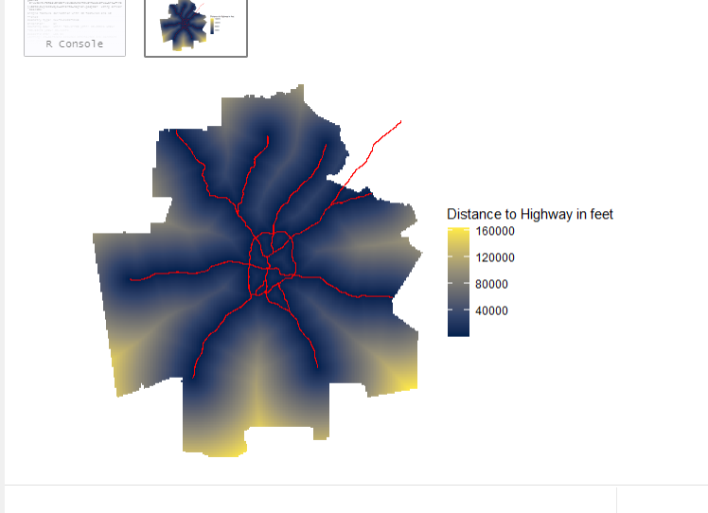

Figure 6 Proximity to Highways

**Population Density**: Indicating residential and commercial growth pressures.

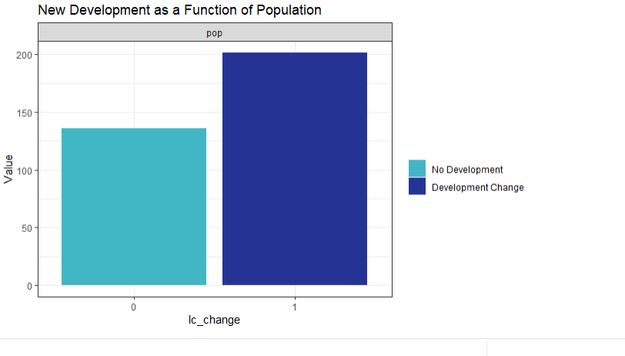

Figure 7 New development as a function of Population

**Spatial Lag of Development**: Capturing the influence of nearby developed areas on a given land parcel.

Figure 8 The Spatial Lag of Development

**Model Performance:**

**Goodness of Fit**: The model’s effectiveness is underscored by McFadden R-squared values, which confirmed its robust predictive capability. These metrics, alongside regression tables, highlight the statistical significance of our predictors. A graph with numbers and text

Figure 8 The Spatial Lag of Development

**Validation & Generalizability**: Despite the optional nature of spatial cross-validation, our preliminary tests ensure that the model’s predictions are reliable and replicable across different parts of the metropolitan area.

Figure 9 Model Cross Validation

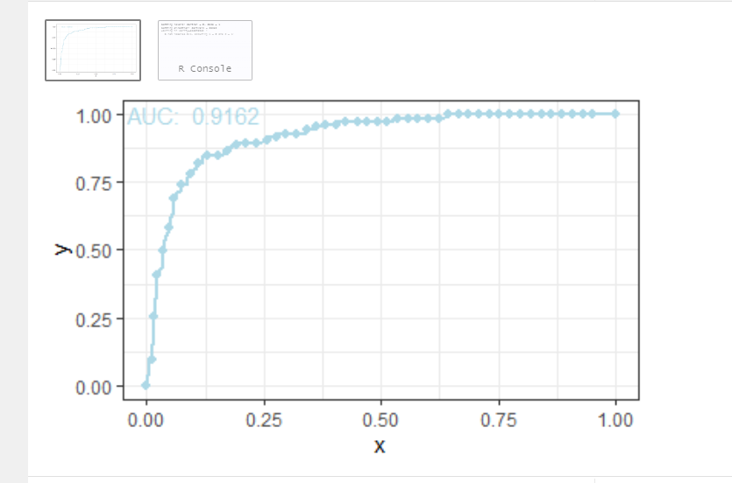

Figure 10 Model ROC Curve

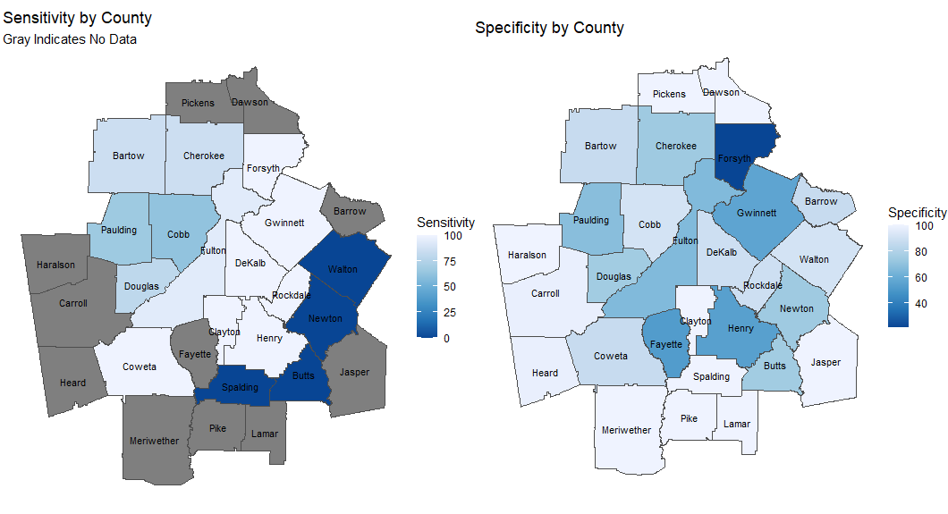

Figure 11 Model Generalizability Across Counties in Atlanta MSA

**Predictive Modeling for 2031**

Leveraging the validated model, we extended our predictions to 2031 using the same variables refined with 2021 data.

**Scenario 1 - Allocating New Development:**

**Population Projections**: Based on the growth trends provided by the Metropolitan Planning Organization (MPO), the Atlanta MSA is forecasted to grow by 1.8 million people by the year 2050. The projected population for the Atlanta region in 2031 is approximately 6.71 million, reflecting an increase of 620,689 people. Our model forecasts where new development is most likely, supporting a balanced approach that considers both growth potential and infrastructure capacity (Atlanta Regional Commission, 2024)

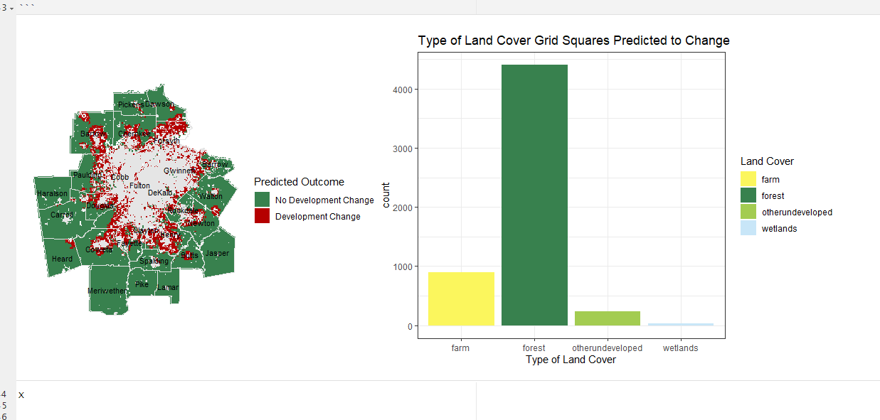

Figure 12 2031 Predictions

**Land Allocation**: Strategic decisions regarding new development areas have been guided by a commitment to environmental stewardship and urban density optimization. We advocate for the protection of ecologically sensitive areas, particularly wetlands, which are crucial for maintaining biodiversity and ecological balance.

**Scenario 2 - Estimating the Effect of New Transportation:**

**Infrastructure Projections:** The introduction of a new highway, as depicted in the "Map of Predictions for New Road," reflects strategic infrastructural development aimed at enhancing connectivity across the Atlanta Metropolitan area. This new highway is anticipated to catalyze development changes by improving access and reducing travel times to central economic zones. The scenario envisions increased development pressure along this new corridor, which is expected to attract both residential and commercial growth due to improved transportation links.

Figure 13 Map of Predictions for New Road

The model uses the proximity to this new highway as a key predictor for urban expansion. The forecasted outcome suggests significant development changes in the adjacent areas, which were previously less accessible. By 2031, these regions are projected to see an influx of new developments, including housing, retail spaces, and business hubs, driven by the enhanced transportation network.

**Discussion and Planning Implications**

Our analysis delineates specific zones that will likely experience substantial development, presenting a refined strategy for managed urban growth. We suggest targeted zoning adjustments aimed at fostering sustainable development and infrastructural improvements to support anticipated population and economic expansion. These recommendations are crafted to bolster economic development while reducing environmental impacts, achieving a sustainable balance in urban expansion.

**Conclusion**

This memorandum equips the Atlanta Metropolitan Planning Organization (MPO) with a detailed blueprint to address the challenges of urban development over the coming decade. With the aid of sophisticated predictive analytics, the MPO is positioned to make informed, forward-looking decisions that will shape the metropolitan landscape sustainably and equitably. Our comprehensive approach ensures that anticipated urban developments are not only foreseen but strategically orchestrated to improve the overall quality of life for Atlanta’s residents, blending growth with sustainability.